**KATHMANDU UNIVERSITY**

School of Engineering

DEPARTMENT OF COMPUTER SCIENCE AND ENGINEERING

**Project Report On**



**University Information System**

**Submitted by**

Anjesh Koirala CS (24)

Biraj Dahal CS (35)

Chandra Rai CS (12)

Kritarth Acharya CS (13)

Rohit Bhattarai CS (42)

Saugat Khatiwada CS (23)

**Project Supervisor**

**Mr. Sushil Shrestha**

Assistant Professor

Department of Computer Science and Engineering (DoCSE)

# ACKNOWLEDGEMENT

Firstly, we would like to thank our supervisor, **Mr. Sushil Shrestha** for helping us to develop our understanding of file handling system through this project. Without such project, we students would not be in a position to implement what we have learnt into our work. Such type of projects has help students to learn cross-platform systems and work on it. We sincerely would like to express our gratitude to Kathmandu University and our project coordinator **Mr. Satyendra Nath Lohani** for providing us such a great opportunities to expand our horizon.

# ABSTRACT

This report contains the introduction, system overview, system design and conclusion of this project (software) University Information System (UIS). It describes the usage of database computer program to store and organize qualitative data. Keeping records of faculties, students and associate members of the university in more precise and secure way is the main objective of UIS. So it is efficient if applications, like UIS are used to handle precious data which is accessed only by authorized member of each department. When data is stored on disk based storage device, it is stored as blocks of data. These blocks are accessed in their entirety, making them disk access operation due to the fact that a number of records can only be stored on one field.

Contents

1.0 INTRODUCTION 1

1.1 BACKGROUND 1

1.2 Problem Statement 1

1.3 Motivation 1

1.4 Objectives 1

1.5 Scope & Limitation 2

2.0 System Design 2

2.1 System Overview 2

2.2 Algorithm 2

2.3 Flow Chart 3

3.0 PROJECT DESCRIPTION 4

3.1. Project Features 4

3.2. Work division 6

3.3 Tools Used 6

3.4 Experience Gained 7

4.0 GANTT CHART 8

5.0 DISCUSSION AND CONCLUSION 9

6.0 BIBLIOGRAPHY 10

**List of Tables**

Table 1: Work Division 7

Table 2: Gantt chart 9

# List of Figures

Login Interface of UIS 7

Second Interface of UIS 8

# ABBREVIATIONS

# UIS: University Information System

# ID: Identity

# INTRODUCTION

## 1.1 BACKGROUND

Computers find a wide range of applications in the modern world. They started as a small machine, which could do calculations in high speed and communicate the results. Now, it would be foolish to say that computers can only control mathematical calculations. They can be used in every field, let it be education, commerce, industries, offices, schools, engineering, or aeronautics. With the inauguration of computers, it will be easier to manage the data in the field, and thus increase efficiency. Also, new innovations can be done using computers, such as creating applications to tackle different problems, and building systems that do specific tasks.

There are many members such as students and staffs in University whose personal data are not possible to record in papers. This may leads loss of data and there would be problem of mishandling it by any of the member. So it is efficient if we use a particular application such as UIS i.e. (University Information System) to handle those precious data which is handled by only single member from each department. This will help us to keep record properly without misusing; the application has a login interface. Only a single person from department can login to the application, he/she has only the authority of logging in to that account. This software contains User ID Password.

## 1.2Problem Statement

We did our best but some of the problems were challenging. Since we are new to such project so it was little bit challenging for us. While doing coding and linking we faced lots of problem, often compiler error occurred. We aimed to keep the information of all teaching and non-teaching staff but due to lack of time and qualification and thus we couldn’t reach our target.

## 1.3 Motivation

Due to the huge amount of records to be kept in a university, it is not This may cause a loss or destroy of data. So we the students of the University are planning to design software which can handle those precious data and records of the members in the University. It helps both the parties i.e. University and Universities members.

## 1.4 Objectives

The main objectives of developing this project are:

* To keep the data and information of faculties, students and staffs of the university by database management system.
* To protect data from unwanted access and alteration by user authentication.
* To make record keeping more reliable and easy accessible by electronic storage.

## 1.5 Scope & Limitation

Our project helps the University to keep the record of all the members like teaching as well as non-teaching staffs and students too. Due to this software it will be easier and reliable to access the information about the members of the University. This software can be used in each department of the university. The University expects satisfactory standards of behavior, conduct and attendance from all its employees. The aim is to ensure prompt, consistence and fair treatment for all employees and do assists in enabling both the employee and the University to be clear about the expectation of both parties.

Talking about the limitation of the software, it only gives the basic information of the members of the university. It does not provide the Universities information which includes the course plan, syllabus, routine etc. rather it only gives the information of the member of the University. Only the member who has authority of logging in this interface can access the data.

# 2.0 System Design

## 2.1 System Overview

Our system helps the University to keep the records of its staffs (teaching & non-teaching) and students. This helps the University to easily access the information about the members of the University. Our software that is compatible with minimum computer requirements can be distributed to other members according to University’s will as it has login interface. As there are many students in University it can be a hassle to get information of students for the staffs. This software provides easy access for the authentic users to get information about the students.

## 2.2 Algorithm

Step 1: Start

Step 2: Open the software

Step 3: Login interface appears

Step 4: Login with correct username and password. (If correct go to step 5 else step 3)

Step 5: Home page appears having options of all the departments.

Step 6: Click on the department whose information is to be assessed.

Step 7: End

## 2.3 Flow Chart

Login

Choose

Department

A

A

Access Student Information

**Fig-2.4.1 Flow chart of UIS login interface**

# 3.0 PROJECT DESCRIPTION

## 3.1. Project Features

Our system will consist of login interface, so when we launch our software we require authentic username and password. This is somewhat first look of our software.

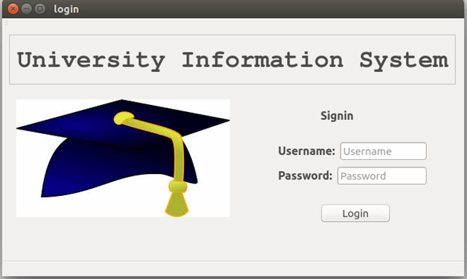

Fig-2.2.1 Login Interface of UIS

This is the first look of this software. This is the login interface. Here the user needs to have valid user name and password to access to this software. In this interface user name and password is entered so get access to the software.

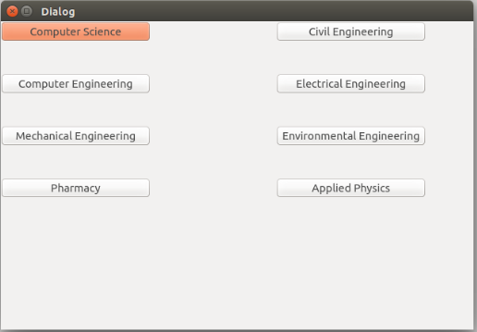

**Fig-2.2.2 Second Interface of UIS**

This is the second interface of UIS. Here the name of different departments are written. When any one of these name is clicked than the other interface having the information of the students of that particular department is accessed.

**3.2. Work division**

Table 3.2. 1: Work Division

|  |  |  |  |  |  |  |
| --- | --- | --- | --- | --- | --- | --- |
| **Work/names** | **Anjesh** | **Biraj** | **Chandra** | **Kritarth** | **Rohit** | **Saugat** |
| **System planning** |  |  |  |  |  |  |
| **System design** |  |  |  |  |  |  |
| **Login interface** |  |  |  |  |  |  |
| **Student interface** |  |  |  |  |  |  |
| **Staff interface** |  |  |  |  |  |  |
| **Database** |  |  |  |  |  |  |

|  |
| --- |
| Assigned work |

## 3.3 Tools Used

**-QT**

QT Creator is a cross-platform C++, JavaScript and QML integrated development environment which is part of the SDK for the Qt GUI Application development framework. It includes a visual debugger and an integrated GUI layout and forms designer. The editor’s C++ compiler from the GNU Compiler Collection on Linux is a Free BSD. On windows it can use Ming or MSVC with the default install and can also use cdb when compiled from source code. Clang is also supported.

**-SQ Lite**

SQLite is a relational database management system contained in a C programming library. In contrast to many other database management systems, SQLite is not a client–server database engine. Rather, it is embedded into the end program. SQLite is ACID-compliant and implements most of the SQL standard, using a dynamically and weakly typed SQL syntax that does not guarantee the domain integrity. SQLite is a popular choice as embedded database software for local/client storage in application software such as web browsers. It is arguably the most widely deployed database engine, as it is used today by several widespread browsers, operating systems, and embedded systems, among others. SQLite has bindings to many programming languages.

## 3.4 Experience Gained

As we were new to this field so this project made our knowledge clear towards C++. We also learned about using database and also making interface of program .We also learned to make perfect report for different projects. We had our perfect coordination among group members and collages.

# 4.0 GANTT CHART

|  |  |  |  |  |  |  |  |  |  |  |  |  |
| --- | --- | --- | --- | --- | --- | --- | --- | --- | --- | --- | --- | --- |
| **Work Week** | **1** | **2** | **3** | **4** | **5** | **6** | **7** | **8** | **9** | **10** | **11** | **12** |
| Program  Analysis and  design |  |  |  |  |  |  |  |  |  |  |  |  |
| File Handling |  |  |  |  |  |  |  |  |  |  |  |  |
| Database |  |  |  |  |  |  |  |  |  |  |  |  |
| Program  Testing |  |  |  |  |  |  |  |  |  |  |  |  |
| Documentation |  |  |  |  |  |  |  |  |  |  |  |  |

|  |
| --- |
| Work completed |

Table 4.0.1: Gantt Chart

# 5.0 DISCUSSION AND CONCLUSION

Overall this software is useful to the university as its keeps the records of students, teachers and staffs. As it is electronic database the records and data is more secured and easily accessible at time of need. This is portable software with most output. This software can be used in schools and even have some tweaks to be used in hospitals and organization. Since this is just the first prototype, it has lots of opportunities to have features with most outcomes.

This software helps the University to keep the information of the faculty members including staffs and students of all departments. This software also helps to keep the data secure by using user authentication. Also we can access to data easily in short period of time whenever needed. We can also edit information of students by our edit mode. Our software is simple and everyone can work with it easily without any problem.

# 6.0 BIBLIOGRAPHY

MySQL, [online], Available at: http://www.mysql.com/downloads/, Retrieved on 30 April, 2015.

http://www.cprogramming.com/tutorial/ado_sql_introduction.html (October 10, 2011)

https://help.ubuntu.com/community/PostgreSQL (July 24, 2012).